Intra-pleural Fibrinolytic Therapy for Adults

The decision to use intrapleural fibrinolytics should always be made on an individual basis by a senior ICU or respiratory clinician.

Types of Intra-pleural Fibrinolytic Agents:
- Streptokinase
- Urokinase
- tPA
Indications:
- Intrapleural fibrinolytic agents are used for flushing the pleural space when drainage is unsuccessful due to fibrinous bands or loculations in the pleural space.
Contraindications:
- Patients with known sensitivity to the particular agent, aneurysm, aortic dissection, bacterial endocarditis, bleeding diatheses, coagulation defects, coma, history of cerebrovascular disease, esophageal varices, pericarditis, recent haemorrhage, recent surgery, recent symptoms of possible peptic ulceration, recent trauma, severe hypertension.

Dose:
- Streptokinase
  - 750 000 IU in 100mL NaCl 0.9% once a day
  - Thoracic drain clamped for 12 hours
  - Repeat for 3 days
    - פרוטוקול מפרופ' נשר – איכילוב
- Urokinase
  - 200 000 IU in 100mL NaCl 0.9% once a day
  - Thoracic drain clamped for 12 hours
  - Repeat for 3 days
    - פרוטוקול מפרופ' נשר – איכילוב
- tPA
- 10 mg of tPA in 100 mL 0.9 % saline for 4 hours twice a day for 3 days
- tPA should not be left in the intrapleural space for longer than 4 hours due to the hemorrhage risk.
- A second course of 3 day tPA can be repeated if necessary.

Equipment:
- Sterile gloves
- Chlorhexidine 2% alcoholic wipe
- Dose of fibrinolytic agent – streptokinase, urokinase or tPA.
- 100 mL 0.9% sodium chloride
- Two 50cc syringes

Administration:
- Ensure drain is correctly positioned
- Reconstitute fibrinolytic agent in 100 ml 0.9 % saline in two 50 ml syringes
- Clean the port with 2 % chlorhexidine.
- Instil the fibrinolytic solution (100 mL) in a sterile manner through the chest drain into the intrapleural space slowly. (inject each 50mL syringe slowly over 20seconds).
- Clamp the catheter after fibrinolytic agent instillation
  - 12 hours for streptokinase
  - 12 hours for urokinase
  - 4 hours for tPA
Monitoring:
- Monitor pulse, BP, respiratory rate, saturation.
- In ventilated patients in addition to the above monitor ETCO₂ and Peak inspiratory pressures.
- Daily complete blood count , INR
- Daily chest xray
- CT scan on day four or earlier if deemed necessary
Cautions:
- If the patient develops respiratory distress and/or hemodynamic instability during the period the intrapleural drain is clamped, the clamp must be released immediately and the doctor called.
- Hemorrhage is a common adverse effect of thrombolytic therapy with a particular risk where there is existing or concomitant trauma.

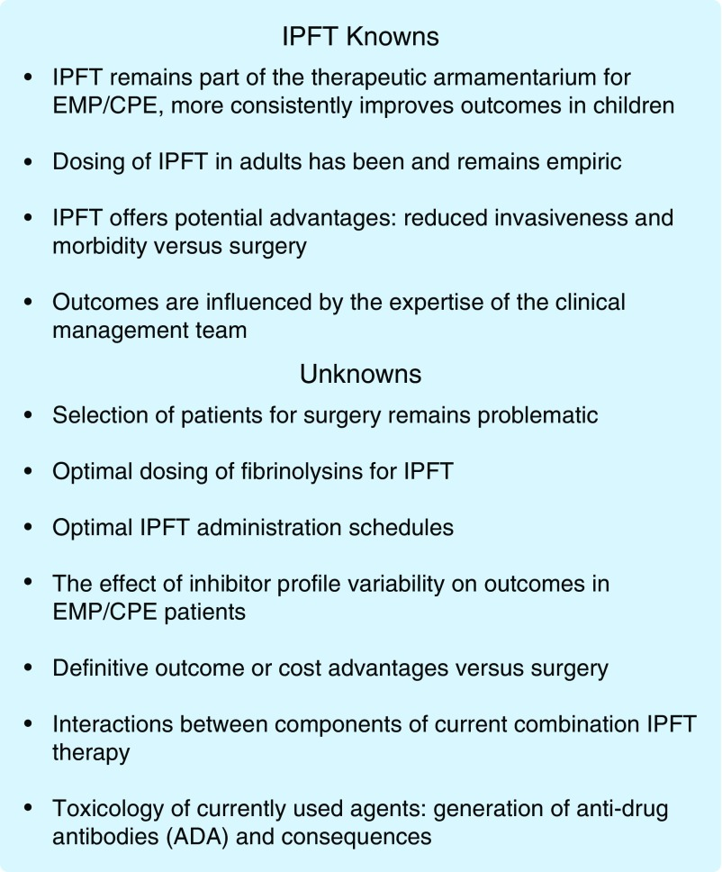
EMP = empyema CPE = Complicated Parapneumonic Pleural Effusion
Intrapleural Fibrinolytic Therapy (IPFT)

Fibrinolytic Agent | Dose | Instillation | Duration of clamping | Duration of treatment
Streptokinase | 750 0000 IU x 1 | 100mL NaCl 0.9% | 12 hours | 3 days
Urokinase | 200 000 IU x 1 | 100mL NaCl 0.9% | 12 hours | 3 days
tPA | 10mg x 2 | 100mL NaCl 0.9% | 4 hours | 3days

